Grazioso Salvare Dashboard Project

Project Overview
The purpose of this project was to develop an interactive dashboard for Grazioso Salvare using the Austin Animal Center Outcomes dataset stored in MongoDB. The dashboard allows users to view, filter, and analyze animal outcome records through an easy-to-use web interface.
The dashboard integrates a MongoDB database, a Python CRUD module, and the Dash framework to provide dynamic filtering, data visualization, and geolocation mapping capabilities. Users can filter data based on rescue categories, view records in an interactive data table, examine breed distributions through charts, and visualize geographic locations using an interactive map.

Required Functionality
The dashboard provides the following functionality:
- Interactive filtering options for rescue categories
  - Water Rescue
  - Mountain/Wilderness Rescue
  - Disaster/Individual Tracking
  - Reset (show all records)
- Interactive data table displaying Austin Animal Center records
- Pie chart displaying animal breed distribution based on currently selected records
- Geolocation map displaying the selected animal's location
- Grazioso Salvare logo
- Unique dashboard identifier displaying the developer's name

Testing Evidence

Screenshot 1: Initial Dashboard State
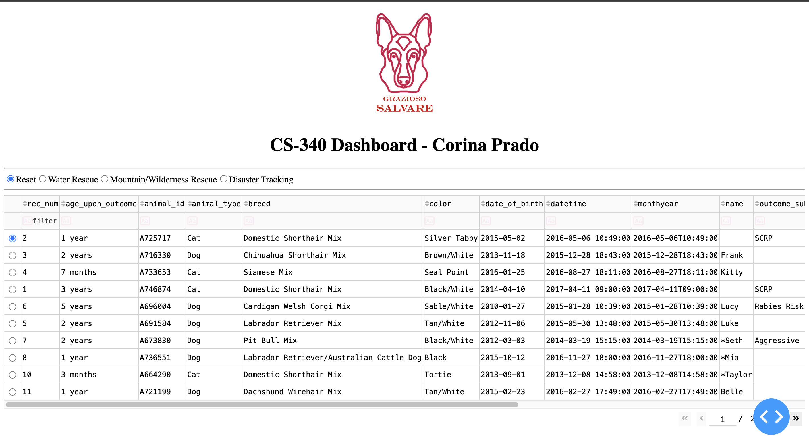

Screenshot 2: Water Rescue Filter Applied

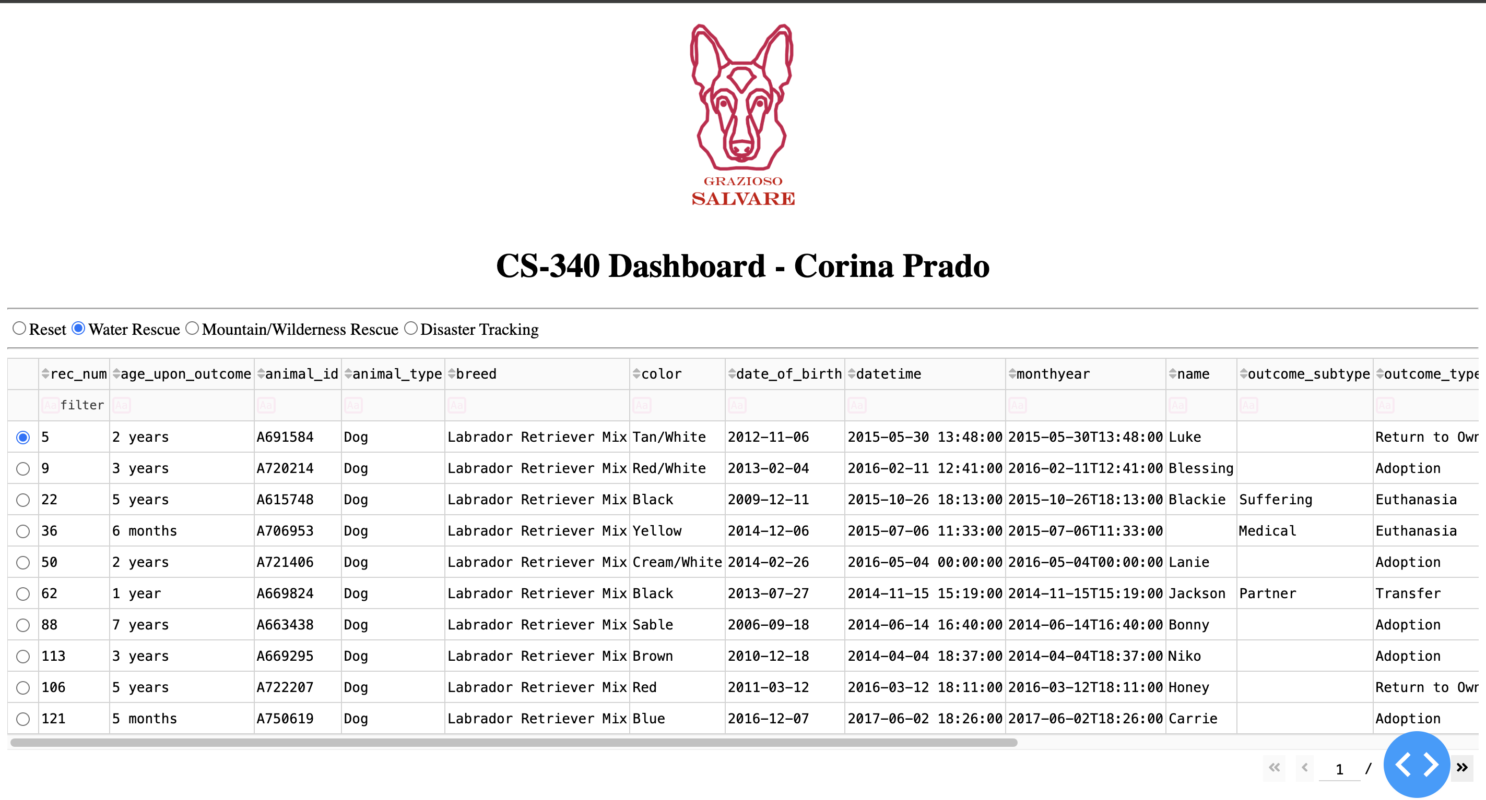

Screenshot 3: Mountain/Wilderness Rescue Filter Applied

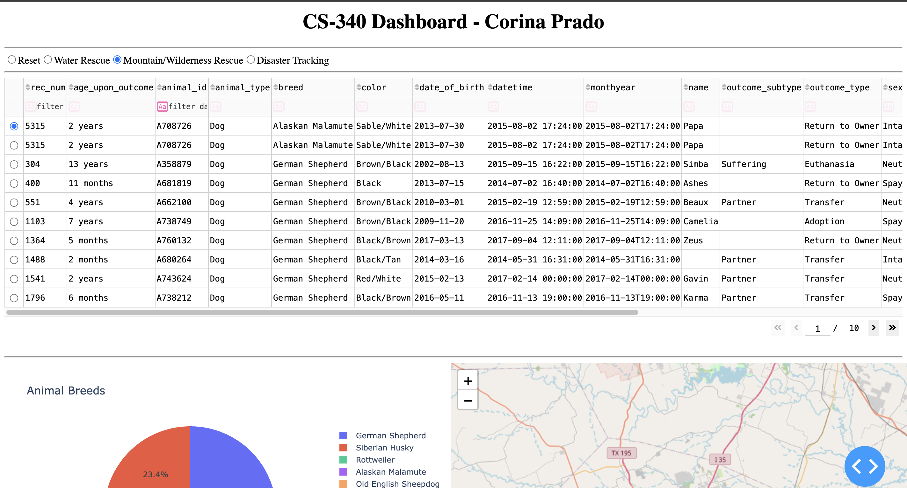

Screenshot 4: Disaster/Individual Tracking Filter Applied
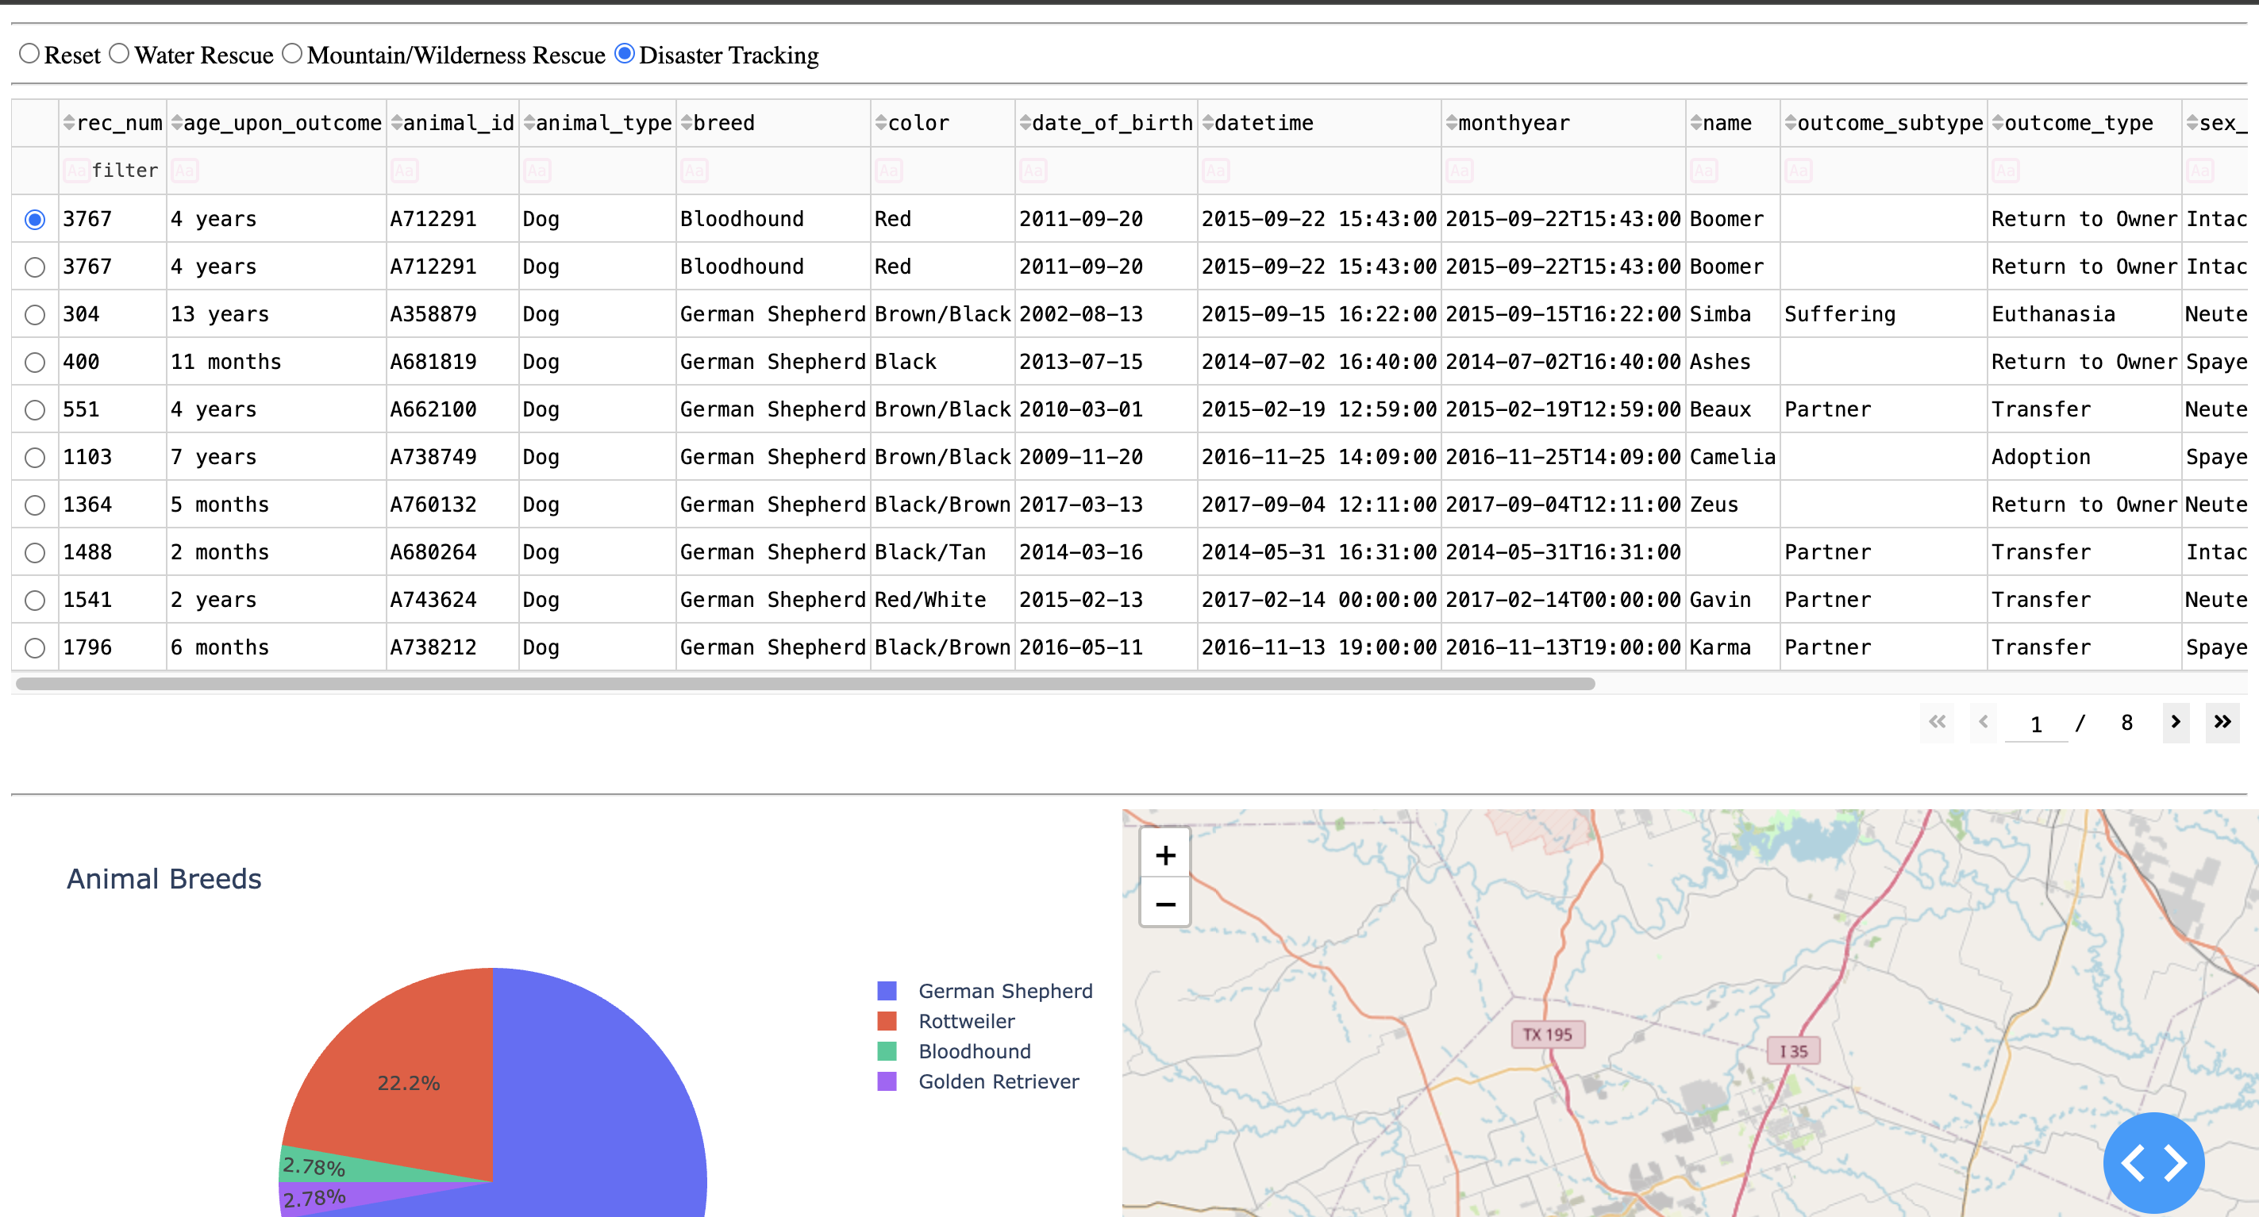These screenshots confirm that the filters, data table, chart, and map respond dynamically to user selections.

Tools Used and Rationale

MongoDB
MongoDB was used as the model component of the application because it provides a flexible document-oriented database structure. The Austin Animal Center dataset was stored in a MongoDB collection, making it possible to efficiently retrieve and filter records.
MongoDB integrates well with Python through the PyMongo driver, allowing database queries to be executed directly from the Python CRUD module.

Why MongoDB Was Used
- Supports large datasets
- Stores records as JSON-like documents
- Fast querying and filtering
- Easily integrates with Python applications

PyMongo
PyMongo was used as the Python driver for MongoDB.
The CRUD Python module uses PyMongo to:
- Connect to MongoDB
- Create records
- Read records
- Update records
- Delete records
The CRUD module acts as the data-access layer between the dashboard and the MongoDB database.

Dash Framework
The Dash framework was used to create the web-based user interface.
Dash provides both the View and Controller portions of the MVC architecture:

View: The View consists of:
- Interactive DataTable
- Radio button filters
- Pie chart
- Geolocation map
- Logo and dashboard header

Controller: Dash callback functions act as controllers by:
- Monitoring user selections
- Updating database queries
- Refreshing the data table
- Updating the chart
- Updating the map

Additional Libraries

Pandas: Used for:
- Loading MongoDB query results into DataFrames
- Manipulating dashboard data
- Preparing chart and table data

Plotly Express: Used to generate the breed distribution pie chart.

Dash Leaflet: Used to create the geolocation map and display animal locations with markers and popups.

JupyterDash: Used to run the dashboard directly within the Jupyter Notebook environment.

Resources Used
- MongoDB Community Edition
- PyMongo Documentation
- Dash Documentation
- Plotly Documentation
- Dash Leaflet Documentation
- SNHU CS-340 Module Resources
- Grazioso Salvare Dashboard Specifications Document

Project Development Process
The following steps were performed to complete the project:
- Imported the Austin Animal Center dataset into MongoDB.
- Created indexes and configured database authentication.
- Developed the CRUD Python module.
- Built the dashboard interface using Dash.
- Added an interactive data table displaying all records.
- Added radio-button filtering controls.
- Connected dashboard filters to MongoDB queries.
- Added a breed-distribution chart.
- Added a geolocation map using Dash Leaflet.
- Added the Grazioso Salvare logo and dashboard identifier.
- Tested all dashboard functionality and verified query results.
- Captured screenshots demonstrating dashboard operation.

Challenges Encountered

MongoDB Authentication: One challenge involved configuring MongoDB authentication and connecting the CRUD module to the database using the aacuser account.

Resolution: The MongoDB user account was verified and the connection string was updated to use the proper username and password credentials.

Logo Integration: The dashboard initially failed to display the Grazioso Salvare logo because the image filename did not match the actual file name.

Resolution: The filename was corrected to match the logo file stored in the project directory.

Conclusion
This project successfully integrated MongoDB, a custom CRUD Python module, Dash, Plotly and Dash Leaflet to create an interactive animal-rescue dashboard for Grazioso Salvare. The completed dashboard provides filtering, visualization, mapping and database interaction capabilities that support animal rescue operations and data analysis.

